#### Mimics

The FT NavVision mimic presentation function provides schematic and graphical overviews of the vessel’s systems like navigation lights, electrical, piping and hydraulic overview.

The screens and mimics presentations are automatically updated with live data of the platform components illustrating components and/or system status.

Via these screens and mimic pages, the operator is able to monitor and control the vessel by using the trackball or touch-screen as a pointing device by selecting elements and their associated commands.

#### General

In general, we say that every page that represents a set of values, switches or any other representation of data is a mimic. The mimics within the system are all freely adjustable within the design stage. After the system is delivered, changes can be made by the NavVision engineers, on appointment. Small changes to the mimic can be made by a trained and skilled operator, who is granted some extra rights in the system. This trained crewmember will have the documentation, so we won’t discuss the changing of mimics in this manual.

#### Mimic examples

Although the mimics are freely adjustable, the main setup will be greatly alike on your screen. Imtech has defined some rules that the mimics have to live up to. This results in an overall recognizable style of mimics that gives it the modern and stylish look and feel.

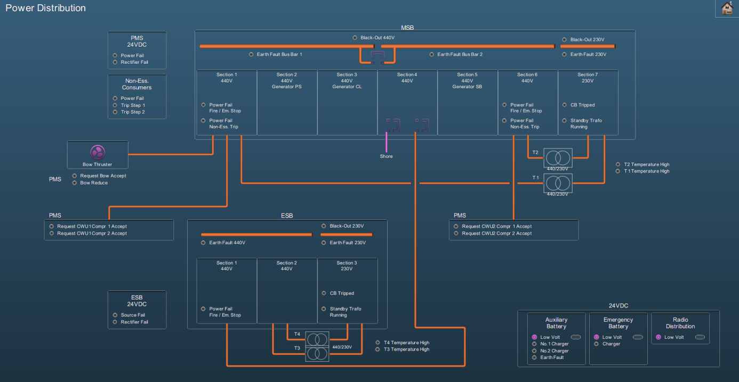

Figure 1‑5: Mimic example 1

#### Reading the mimic

Some installations contain a special *legend* mimic. This mimic explains the symbols, variations, colors etc. that you can find in your system’s mimics (see Figure 1‑6). If there is ever a doubt in what you observe on the mimic you are watching, please refer to this mimic.

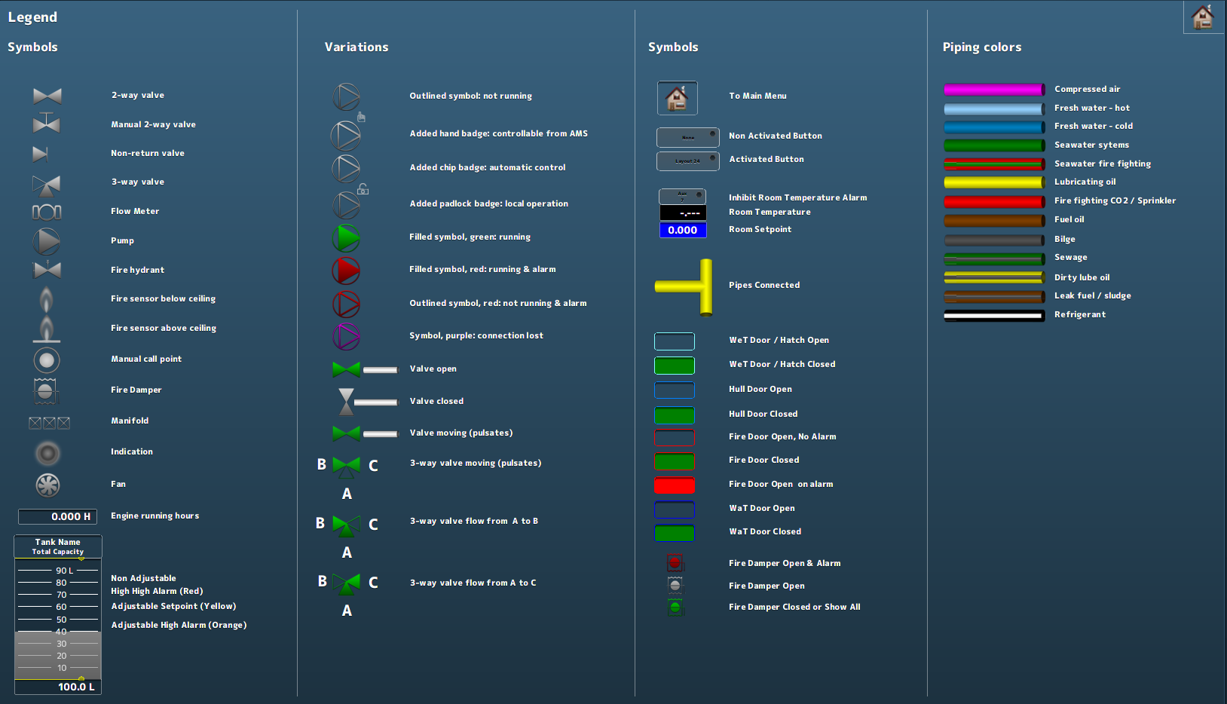

Figure 1‑6: Legend mimic

Other mimics can show a variety of information. There can be mimics for power distribution, tank volumes (see Figure 1‑7), fire alarms and many more. It is also possible that you have a combination of subjects on one mimic. Mimics are perfectly capable of displaying camera feeds or trend graphs.

As a special feature you can show the alarm list or the logbook on (part of) the mimic (see Figure 1‑8).

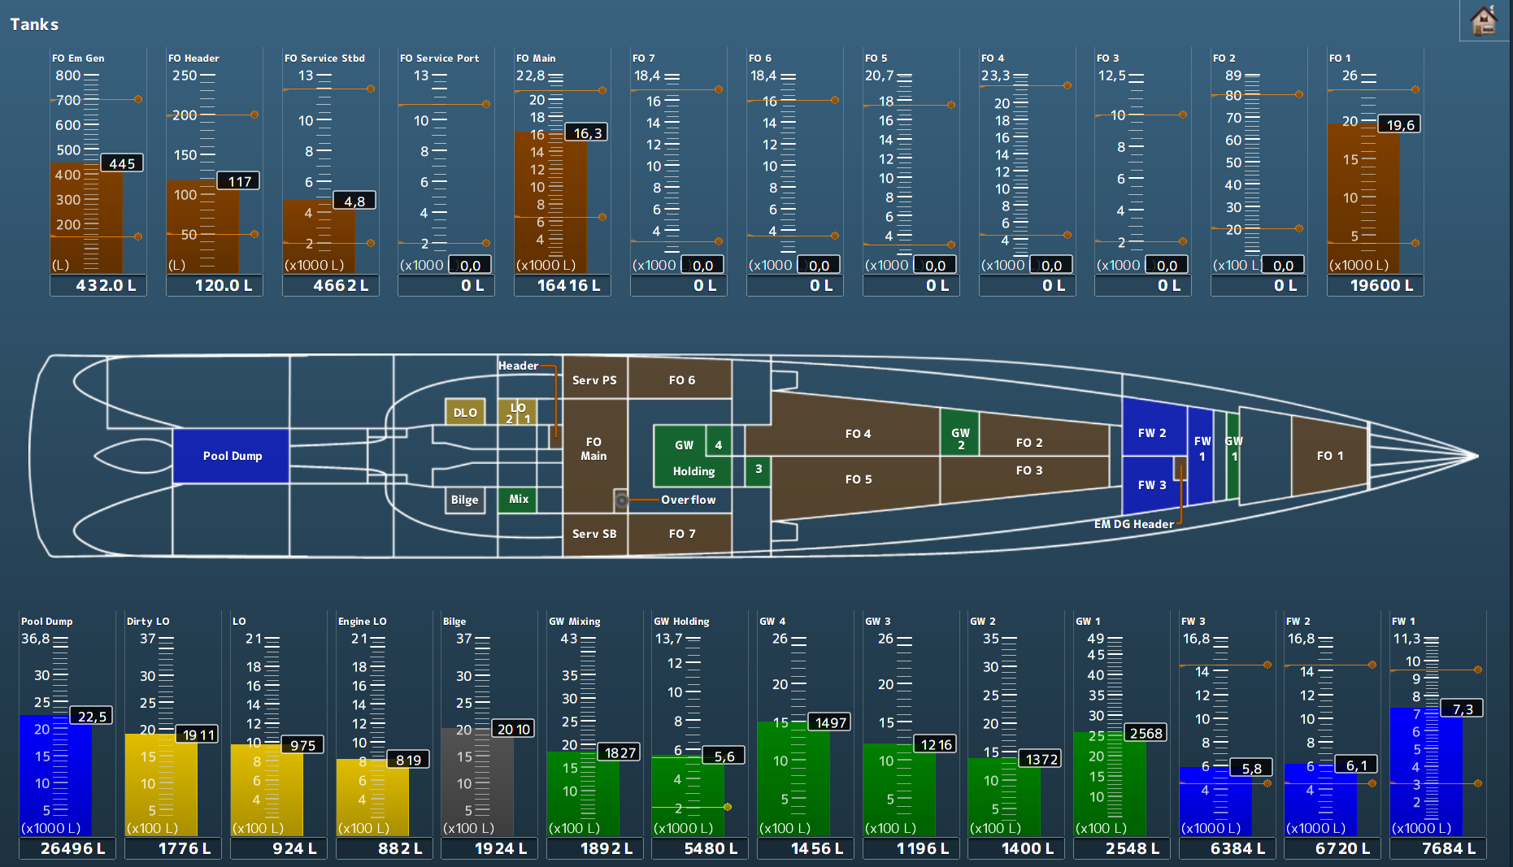

Figure 1‑7: Tank mimic

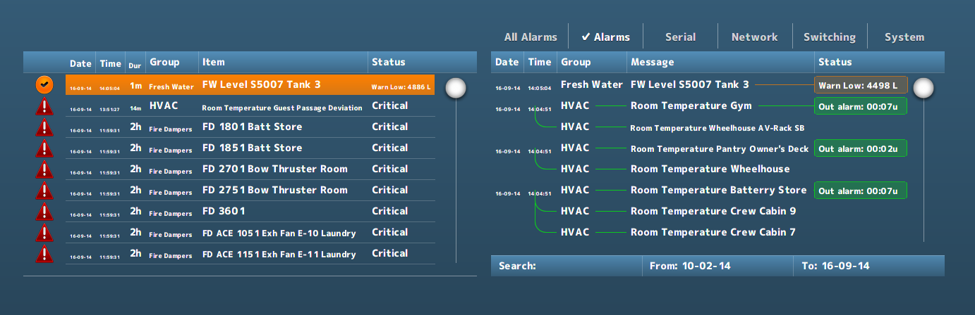

Figure 1‑8: Alarm list and logbook in mimic